Educating to Prevent:
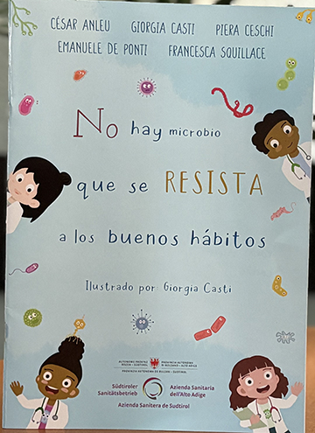
A Health Initiative Beginning in Childhood
On February 18, Cabrini Guatemala officially presented the children’s book “No Virus Can Resist Good Habits,” an educational initiative that responds to one of today’s most pressing health challenges: the misuse of antibiotics and the growing problem of antimicrobial resistance.

This project was born from the commitment of a team of healthcare professionals, including a pediatrician from San José Dispensary - Dr. Cesar Anleu and Dr. Piera Ceschi, a veterinarian, in collaboration with international professionals from the Master’s Program in Global Health.

The event was also broadcast via ZOOM and included the following content: 1. Cabrini Guatemala – Mission and Work. Dr. Wilber Pereira 2. Antimicrobial resistance in our environment. Dr. César Anleu 3. Book presentation: a) Dr. Piera Ceschi b) Dr. Giorgia Casti c) Francesca Squillace
This book is the result of the experience of Dr. César Anleu, paediatrician at the San José clinic, and Dr. Piera Ceschi, veterinarian, who in 2022 completed her Master's degree in Global Health in Guatemala. Both professionals were interested in developing educational and scientific material for children on the proper use of antibiotics, as a way to influence the practice of self-medication and the indiscriminate use of these drugs. Dr. Giorgia Casti, Francesca Squillace (midwife) and Dr. Emanuele de Ponti joined this initiative.
Inspired by the realities faced daily by the families served in our dispensaries, they chose to address this issue in a simple and approachable way—by educating children.

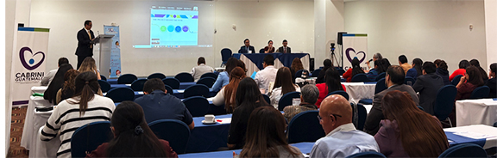
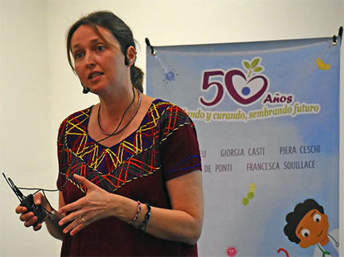
The book uses accessible language and friendly illustrations to teach essential habits such as proper handwashing, avoiding self-medication, and the responsible use of medicines. In this way, it promotes awareness from an early age and helps build a culture of prevention within the community.
Healthcare professionals gathered in Guatemala to present the children’s book on the misuse of antibiotics.

The authors emphasized the importance of health literacy and educating children on these issues, focusing on children’s ability to understand and, even more importantly, to be part of the solutions in the future.

The event brought together partner institutions and representatives from national entities such as the Ministry of Health and the Ministry of Agriculture, along with professionals committed to promoting public health. It was a meaningful space for dialogue, collaboration, and shared commitment to the common good.
Dr. Piera Ceschi completed her Master’s Degree in Global Health in Guatemala.

Children from our programs played a special role during the presentation, reading from the book and sharing short messages of gratitude. Their participation reflected the concrete impact of this initiative and reminded all present that education is a seed of hope.

The book is distributed free of charge and may not be sold and is intended to contribute to efforts to combat this global health problem. It is written in English and translated into European and Latin American Spanish, Italian and German. The Missionary Sisters have a digital version available to share with those who are interested, especially, Cabrinian institutions around the world.

At Cabrini Guatemala, we reaffirm our commitment to integral health and education as tools for social transformation. We believe that forming good habits today is caring for the future of the next generations. ~ submitted by Sr. Maria Elena Plata Alvarado, MSC, Madre Cabrini Dispensary & Vannesa Duenas, Cabrini Guatemala
Cabrini Cares Day Spurs Action

On Saturday, February 21, a group of about 30 people from five parishes and the surrounding neighborhood gathered at St. Frances Cabrini Shrine in New York City for the first Cabrini Cares Day. The topic was helping the homeless. Pietro Bartoli of the Community of Sant’Egidio spoke about the scope of the housing problem in New York, its causes, and how everyday people can engage those who are, in his words, “Having the worst day of their life almost every day.”

Questions flew almost as fast as practical tips and ideas. Pietro noted that the most important thing we can do is to live up to our Christian calling to look at each person as a human being. "Yours may be the only smile that person receives all day,” he said. Tips offered by other participants included:
- If you offer someone a granola bar and they refuse, don’t be offended. You wouldn’t take it personally if you offered a friend food and they said no. And you don’t know if the person has already eaten ten granola bars in the past two days.
- Set yourself a policy on how you’re going to handle requests and stick to it. That way you’re not faced with a decision (and temptation) every time you’re asked.
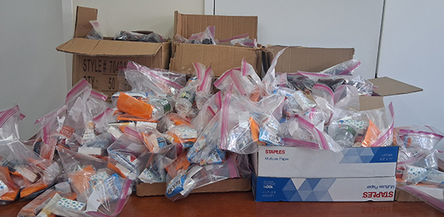
- If you choose to give money, do it without strings or judgment attached.
At the close of the session participants put together 100 hygiene kits and 100 warming kits. Everyone took as many kits as they thought they could hand out. The remainder were given to the Community of Sant’Egidio, which does outreach to the homeless twice a week.
Participants of the first ‘Cabrini Cares Day’ assembled 100 hygiene and 100 warming kits for those experiencing homelessness.

The group will meet again to do role-playing on how to engage the homeless, and to create additional kits. ~ submitted by Julia Attaway, Executive Director, St. F.X. Cabrini Shrine, NYC
Love One Another…Pass It On
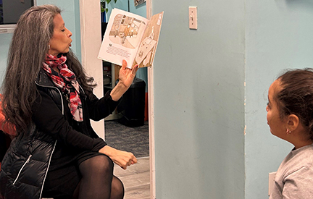
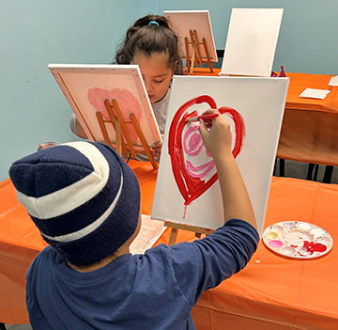
Cabrini Immigrant Services, Dobbs Ferry (CIS-DF), held a STARS (StoryTelling, Art, Reading and Socialization) for Kids Program for students in Grades 3-4. Dr. Wendy Mages, a trained storyteller, told the story, Somebody Loves You, Mr. Hatch, by Eileen Spinelli. The story is about a man who kept to himself. One day, he received a heart-shaped box of candy with a note that said, “Somebody Loves
Dr. Wendy Mages, a trained storyteller, tells a story about caring for others, especially those who are all alone or lonely.

You.” This note changed his whole life. He went out more, was friendly, and seemed so much happier. Sadly, he found out that the package was sent by mistake. He went back to his old self until his neighbors came together and let him know how much he was loved.

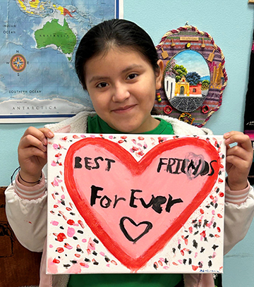
After listening to the story, the children had a wonderful discussion about how important it is to be accepting and loving of others. They spoke about bullying and how some children don’t have any friends. The children discussed ways that they can help make others feel more comfortable and loved. They painted a poster showing ways they can be loving and kind to others. The hope is that others will see the posters and also spread love. They reminded us that our actions speak louder than our words. The children are going to make more of effort to sit with someone when they are alone, talk to someone who seems sad and just spread love.
Young artists at work.
The final masterpiece!

Everyone loved the story. In fact, many said that it was their favorite one. They were so happy to receive a copy of the book so they can not only share the story but they can also share the love. ~ submitted by Lorraine Campanelli, Director, CIS-DF

Immigration in the News
The following are links to articles/podcasts regarding immigration that have recently appeared in Catholic publications and on websites:

- U.S. Border Bishops Urge Change on Deportations
- Catholics Speak Out on the Violence Against Migrants
- Vatican Migration Chief: Expand Legal Pathways
Detained friends find themselves isolated from all contact with family and friends. Someone to write and correspond with can make a big difference.
Even if you don’t personally know someone who is detained or if you can’t visit a detained friend at the detention centers, you can reduce their isolation by writing to them regularly, helping to accomplish many of the same ends as face-to-face visits. We especially need people who can correspond in Spanish.

Here is a way in which to support those in immigration detention by becoming a pen pal. To learn more click here The organization is known as FirstFriendsNJNY.org
To learn more about Justice for Immigrants and ways to get involved, click here

UPDATE PUBLICATION SCHEDULE
Due to the MSC Assembly and scheduling in the Province Communications Office during the week of March 8th, The Update will not be published on
Thursday, March 12th. Kindly note this when planning Update submissions. Thank you.
Publication will resume on Thursday, March 19th.

As has been our tradition, the Cabrini Lay Missionaries (CLM) will be journeying with us through Lent by sharing reflections and meditations each week. The reflection for the Second Sunday of Lent is offered by Lorraine Campanelli, CLM, Director.
The Second Week of Lent
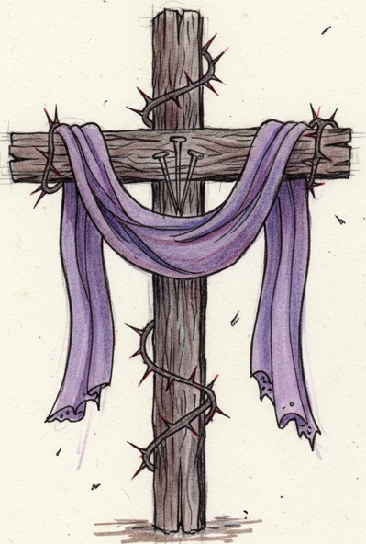
The Gospel for this Sunday (Matthew 17:1-9) is the Transfiguration. What a timely reminder as we begin the second week of Lent. As I reflected on the Gospel, I felt like I was being invited to a different type of transformation, a spiritual one. Lent calls us to pray, to listen and to reflect on the Word of God, so we can get closer to our Lord. Through these practices, we also draw closer to each other. When we put on Christ, we become people with deeper love, deeper respect and deeper understanding. Pope Leo XIV’s Lenten message asks us to not only listen and fast but also to abstain from hurtful words. He encourages us to place God at the center of our lives. I’m sure each of us has a way of drawing closer to God. When I think of placing God at the center of my life, I am reminded of a prayer that St. Clare of Assisi used as she gazed upon the San Damiano Cross. One of the lines from that prayer is:

Gaze upon Christ, consider Christ,
contemplate Christ, contemplate Christ.
Perhaps during this week, we can spend some time gazing upon the Cross and repeating the words of St. Clare. Let us pray that we will have a spiritual transformation. ~ Lorraine Campanelli, CLM, Director

Prayer Requests

Missionary Sisters of the Sacred Heart of Jesus
Please keep the Missionary Sisters in your prayers as they gather for their Assembly during the week of March 8th. May their deliberations be inspired and guided by the Holy Spirit and may all travel safely to and from the meeting.

