May is the Month of Mary

“Tis the Month of Our Mother,

Those blessed and beautiful days,

When our lips and our spirits

Are glowing with love and with praise.

All Hail to thee, dear Mary,

the guardian of our way;

To the fairest of all Queens

Be the fairest of seasons, sweet May.

*~ Eleanor Cecilia Donnelly written in 1850*

*~ A Note of Appreciation*

**A**s everyone worldwide has been mourning and celebrating Pope Francis, and rightly so, we Cabrini-types have certainly appreciated his consistent call to pay attention to the poor and marginalized, the migrants and refugees. He has given constant clarion calls to see our sisters and brothers. Not unlike my favorite line in the “Cabrini” movie when Mother, leading the sisters into Five Points and its ghastly scene says: “Don’t look away. See everything.”

**B**ut these moments have also made me aware of the call being given to me, personally, by organizations right in my own province of Guadalupe. Every one of our missions and ministries makes great efforts responding in their own way and capacity to the needs beyond the “usual customers.” Hats off to everyone for your witness to me.

**B**ut for me, right up close, there are works going on in direct service to the ones I am asked to see. I am noting our two Cabrini Immigrant Services programs (CIS NYC, CIS-Dobbs) and our Guadalupe Immigration Commission. You are the ones who look at the faces full of fear, confusion, hurt and sometimes, just anger. You are the ones who help with complicated forms to find housing, schools, banking, jobs, food. You are the ones who have receive the trauma of others and try to offer help to deescalate the chances for further trauma. With gentleness and understanding, each day you open the door to the next flood of fearful, hopeful faces. Do they sometimes haunt you afterwards? I suspect that at the end of the day you go home and answer other needs. You let me know of opportunities so I can do my small part in letter writing, advocacy, finding books, whatever. You are the ones who invite me with the province to pray each month for our sisters and brothers. How contemplative is that! You are the ones who let children play, read books to them and others finding books that the children can read in their own language. How neat is that! This all done in shoebox size places, all on shoestring budgets. You invite hundreds of volunteers into your work so they can also help stock food, clothes, socks, scarves, to give away. You share God’s call with them.

**F**or me, you make our legacy and heritage alive, not just in exhortations and great celluloid moments. You shout our call from rooftops. You make the gospel be here, now, not to be ignored.

**P**lease accept my deepest respect and deepest gratitude for your witness to me,

***Eileen Currie, MSC***

Dances that Dazzle!

Cabrini Immigrant Services – Dobbs Ferry (CIS-DF), NY, was so excited to share the talent of Nathalie Carolina Ortiz Cabrera, a professional ballerina, with the residents of St. Cabrini Nursing Home. Nathalie, a friend of Shirley Godoi, the Administrative Assistant at CIS-DF and her family, is visiting from Paraguay. She performed various ballets and some traditional Paraguayan folk dances. One amazing dance was the traditional ‘bottle dance.’ Nathalie danced with 2 bottles on top of her head. Everyone watched in amazement. She changed into different costumes; each one was more beautiful than the next. One costume was a white dress with a beautiful black shawl. This was the traditional Paraguayan dress.

Nathalie Carolina Ortiz Cabrera, a professional ballerina performed a variety of amazing dances for the residents of St. Cabrini Nursing Home.

As a special thank you, Natalie prayed the Our Father in Guarani for everyone present. Nathalie speaks Spanish and Guarani, a common indigenous language of Paraguay.

It was such a beautiful afternoon. The residents thoroughly enjoyed the performance. They did not want the show to end.

Nathalie in a traditional Paraguayan dress.

~ *submitted by* *Lorraine Campanelli, Director, CIS-DF*

**Cabrini Dads Make Jazz Fest Parking**

**~ a Favorite Tradition for All**

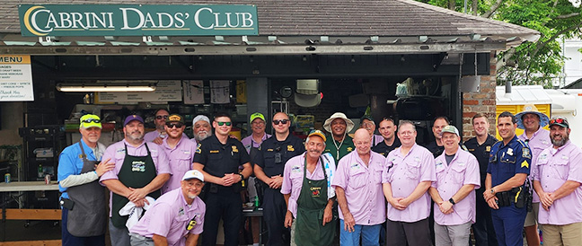

Parking at Cabrini High School for Jazz Fest is as much of a tradition as Jazz Fest itself! The Cabrini Dads are ready for the crowds on the first day of the New Orleans Jazz and Heritage Festival.

At Cabrini High School, forming young women into the faith-filled leaders God intends them to be is at the heart of everything we do. But behind the scenes, it takes more than just dedicated faculty and staff—it takes the commitment of our incredible Cabrini dads.

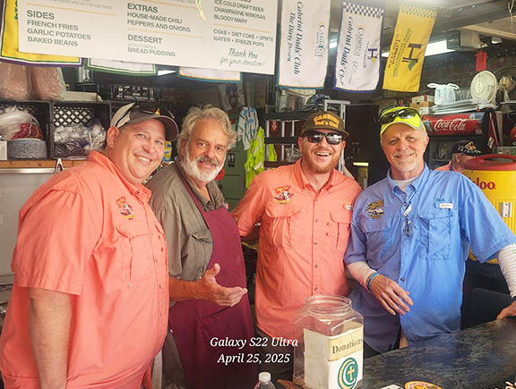Each year, the Cabrini Dads’ Club works tirelessly to raise funds that directly support student education. Their biggest and most beloved fundraiser? Parking for the New Orleans Jazz and Heritage Festival.

Just blocks from Cabrini’s Bayou St. John campus, Jazz Fest draws world-class musicians, artists, and food lovers from all over for eight days at the end of April and the beginning of May. And for many of them, parking at Cabrini has become part of the tradition. Expertly managed by the Dads’ Club, Cabrini offers safe, secure parking and something more: a tailgating experience that’s as memorable as the festival itself.

The grill and a famous Dads’ Club burger with fries and special sauce is all part of the experience of parking at Cabrini High School.

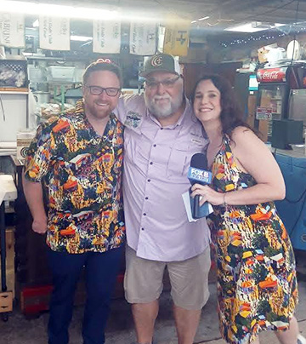For more than 40 years, Cabrini dads have transformed the Dads’ Club garage into a hub of hospitality—grilling burgers, playing music, and welcoming festivalgoers with signature warmth. It’s a one-of-a-kind atmosphere where many return year after year, their Jazz Fest experience incomplete without a twilight burger and a wave from a dad in a Hawaiian shirt.

Their generosity and spirit haven’t gone unnoticed. So beloved is the Dads’ Club that local news crews make it a point to stop by each year—not just to cover Jazz Fest, but to spend time with the dads themselves. They’ve become part of the festival’s story—not because they’re out to make a buck, but because their fundraising transforms lives.

That transformation is felt every day on campus. As one of Cabrini’s largest benefactors, the Dads’ Club has played a major role in supporting curriculum enhancements, capital improvements, and state-of-the-art technology—projects that keep Cabrini competitive in one of the most rigorous Catholic school systems in the country.

Each year, news crews like Fox 8 make CHS their home base highlighting Jazz Fest and CHS’ historic campus.

While we love celebrating the success of our students, it’s just as important to honor those who make that success possible. Cabrini is a family, and these faithful stewards in baseball caps are a vital part of it. Their work isn’t just service—it’s a legacy of love.

~ *submitted by Anne Argus DiPaola ’96, CHS Director of Communications*

_______________________________________________________________________________________

**EMAIL NOTICE**

For those Update subscribers who have had an @Cabrini.edu email address, we are requesting that if you would like to continue to receive The Update, to kindly send your preferred email address to:

[cabrininews@mothercabrini.org](mailto:cabrininews@mothercabrini.org)

As of May 15th, we will discontinue sending to the @cabrini.edu addresses.

Thank you for your kind attention to this matter.

***In this Jubilee Year of Hope, we have invited the Missionary Sisters of the Guadalupe Province, Cabrini Lay Missionaries, and members of the Cabrinian community to reflect upon and share What gives YOU hope? We invite YOU to send your reflections (and a headshot) on HOPE to:*** [***cabrininews@mothercabrini.org***](mailto:cabrininews@mothercabrini.org)

***Sr. Patricia Dunleavy, MSC***

**Hope for me is the outward sign of the works of the Holy Spirit by the prayerful lives of men and women that change our world by their actions of love and service to their brothers and sisters. This makes me believe holiness is alive and possible.**

**Change of Email Address**

Sr. Christine Marie Baltas, MSC has a new email address:

[Pbaltas40@gmail.com](mailto:Pbaltas40@gmail.com)

Kindly make a note of that change.

Prayer Requests

***Religious Brothers***

We give thanks for the lives of Religious Brothers whose vocations we celebrate today - May 1st - on the Feast of St. Joseph the Worker. Bless them in their vocation as they minister to the people of God in myriad ways.

To read more about Religious Brothers Day and to access prayers for them, please visit the NRVC website [here](https://nrvc.net/292/publication/11357/article/13029-religious-brothers-day)